**Assignment 2** (20%)

CSE 5120 (Section 01) – Introduction to Artificial Intelligence – Fall 2024

*Submitted to*

Department of Computer Science and Engineering  
California State University, San Bernardino, California

*by*

Alexis Naranjo (008347411)

(Your collaborator in this homework (if any))

Date: *December 6, 2024*

*Email:*

* *008347411@coyote.csusb.edu*
* *Your collaborator’s email (if you collaborated with any)*

**Assignment Report**

Brief description of your work here acknowledging your collaboration with your class fellow (or a friend from other CSE 5120 section), and the capacity at which he/she collaborated with you, followed by the algorithms you implemented.

1. **digitRecognizer.py for MNIST dataset**

Your brief explanation of the dataset, your code solution, and any documentation with screenshots of your code Evaluation (results from digitRecognizer.py)

**Answer:** The dataset we used was MNIST which stands for Modified National Institute of Standards and Technology which was processed by Yann LeCun, Corinna Cortes and Christopher Burges. The dataset consists of data gathered from the NIST which was then modified to be used for machine learning. The data gathered are images of handwritten numbers used to help train machines to identify written digits. The dataset we are using to test the model we developed are images of handwritten numbers that are the digits 1 through 9. Our solution to have the machine to try and make accurate predictions on the handwritten digits is to first to develop a CNN model that was trained by the MNIST dataset. I trained the model with two convolutions with 30 layers each and two dense layers with one having 128 units and the other having 10 units. I also used 10 epochs for the training which achieved an accuracy of 99%. After creating the model, I then tested the model on the on the 9 images of handwritten digits which resulted in the machine correctly predicting 8 out of the 9 numbers that we passed through the model. The output of the digitRecognizer python file shows the 10 epochs with the loss and the accuracy of each one and the predicted class/digit of each handwritten digit image with the percentage that the machine believes that image is the class/digit it predicted.

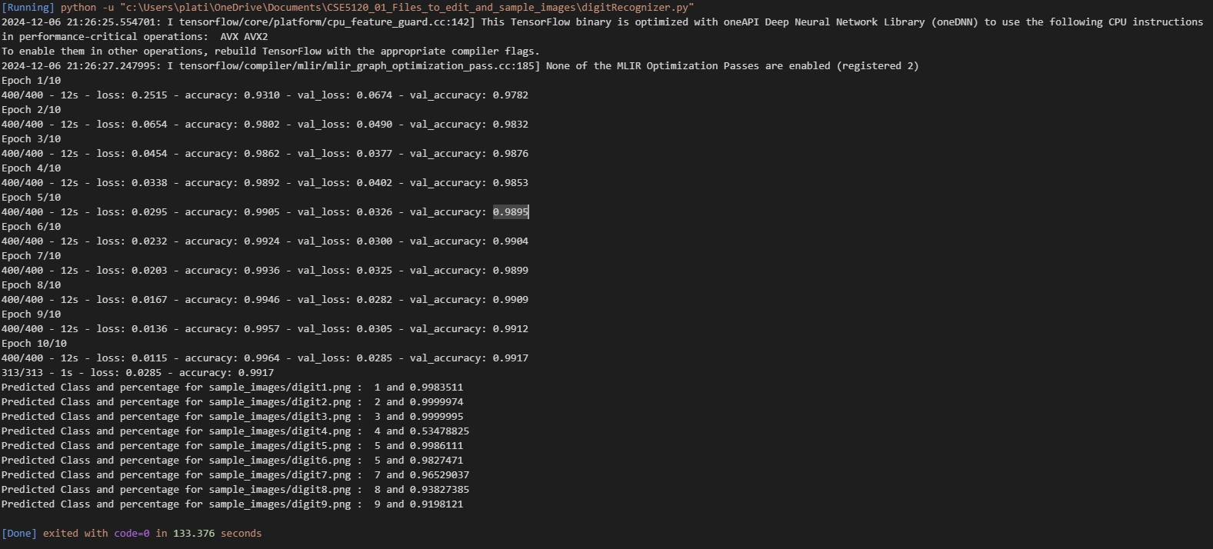

1. **Evaluation (evaluation.py) for your model performance evaluation**

You can also provide brief description of your code written in evaluation.py to load your saved model that can be readily used on test dataset for the staff.

**Answer:** The code written in the evaluation file is very similar to the one that is written in the digitRecognizer file except for the code that develops and creates the CNN model and saves it. This file instead loads the saved model from the file that we saved it to from the previous file to be able to just test the model in this file. The output for this file is also different from the other one in that it doesn’t show the epochs as the model is not being developed here. It however does still show the overall accuracy of the model and the same predictions that the machine made on the images with the predicted class/digit and percentage for that prediction for all the images of the handwritten digits 1 through 9.